[Tech Journal Link](https://github.com/James19995/SYS350-wiki/wiki/SRM---Site-Recovery-Manager)

**Module 1 - VMware Site Recovery Manager Introduction**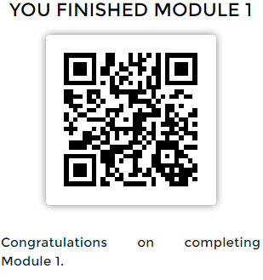

**Take a screenshot of Main Console. This is the first thing you see once the lab is loaded.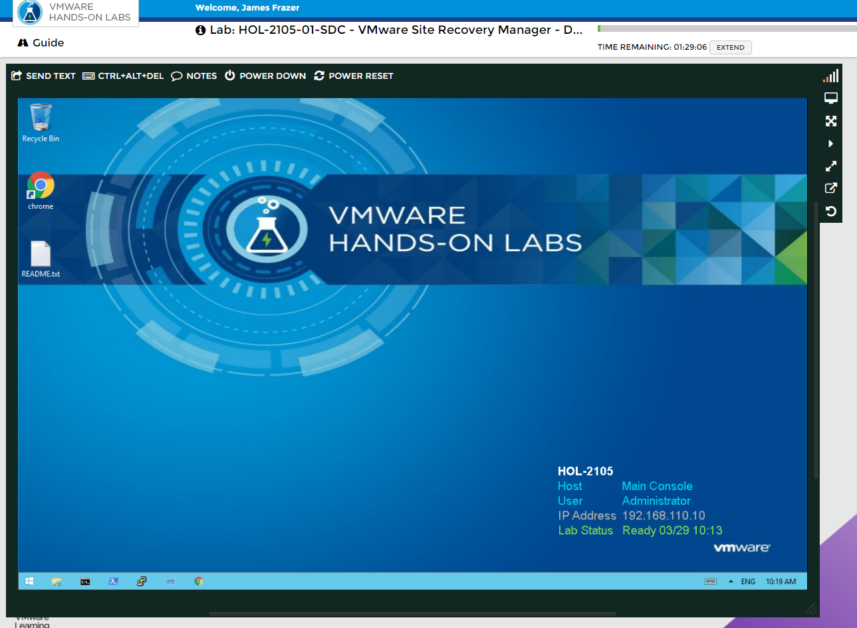 Take a screenshot of the Site Recovery Manager Summary page - showing that you've successfully logged into SRM.**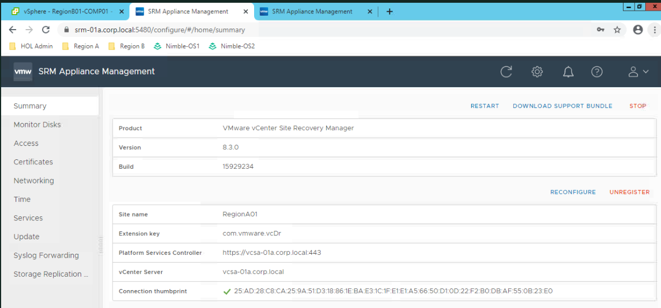

**- What version of vCenter is being used in Site A and Site B?**

8.3.0

**- How many protection groups are configured in this instance of SRM?**

2

**Module 2 - Failing over a Virtual Machine with Site Recovery Manager**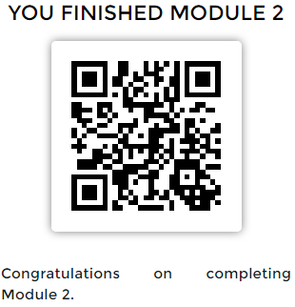

**- How many Recovery plans are there?**

2

**- What is a protection group?**

A protection group is a collection of virtual machines that Site Recovery Manager (SRM) protects together.

**- What is a recovery plan?**

A recovery plan is like an automated run book. It controls the steps of the recovery process, including the order powers on and powers off virtual machines, the network addresses that recovered virtual machines use, and so on. A recovery plan includes one or more protection groups. (You can include a protection group in more than one recovery plan.)

**Take a screenshot of the virtual machines replicated from Site A.**  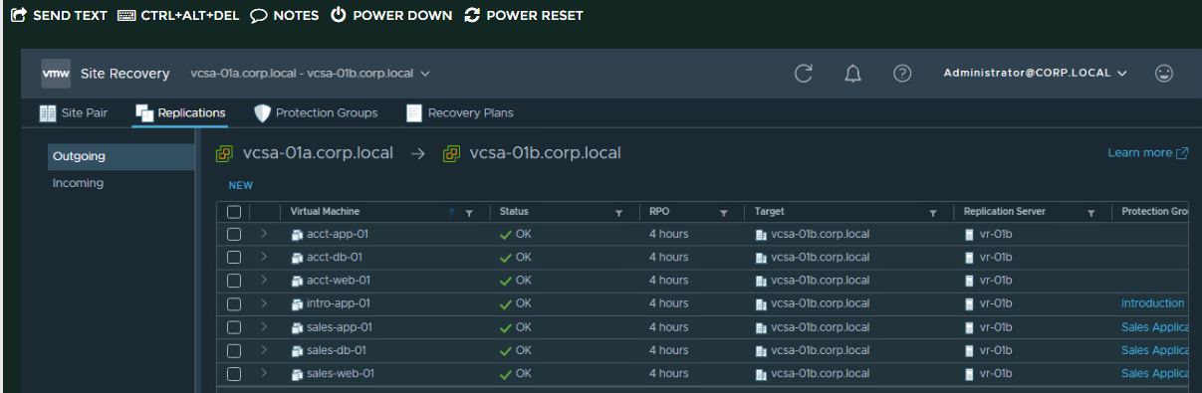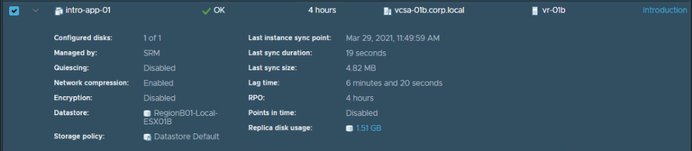

**- What is the replication status of the intro-app-01 VM?**

OK

**Take a screenshot of your recovery in progress**

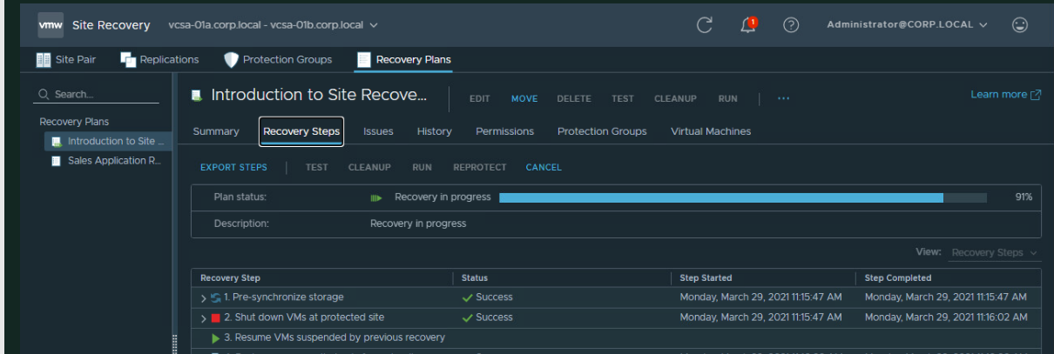

**Take a screenshot of the completed recovery.**



**Take a screenshot of the Intro-App-01 VM running in Region B.**

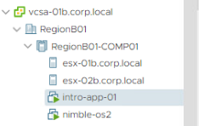

**Take a screenshot of the "Recovery Steps" tab in the "Introduction to Site Recovery" Recovery Plan.**

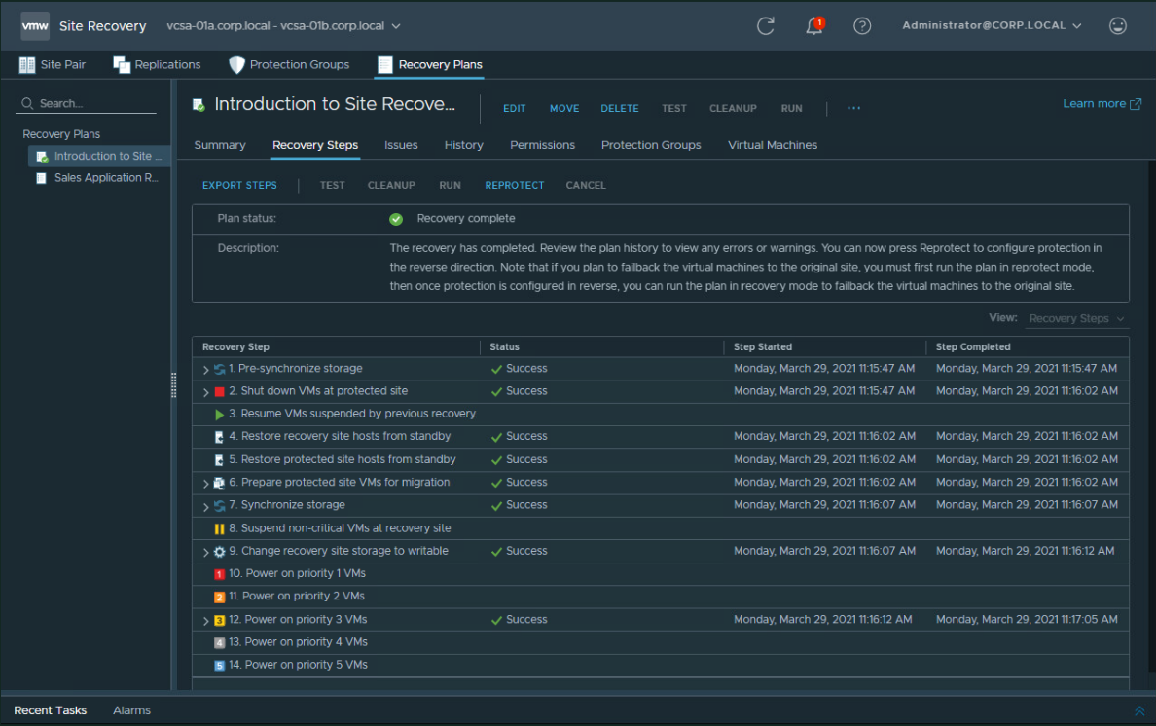

**Take a screenshot of the Reprotect in progress.**

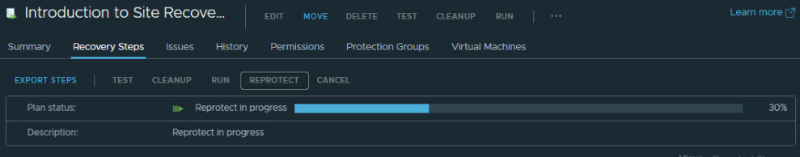

**Take a screenshot of the Recovery Complete status.**



**Take a screenshot of the Intro-App-01 VM running in Site A again.**

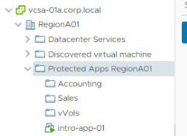

**Module 3 - Executing a Disaster Recovery Plan using Site Recovery Manger**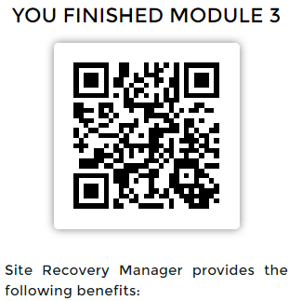

**Take a screenshot of your new protection group.**

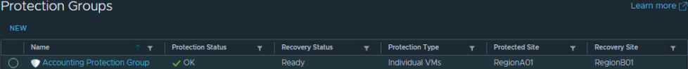

**Take a screenshot of your new recovery plan.**

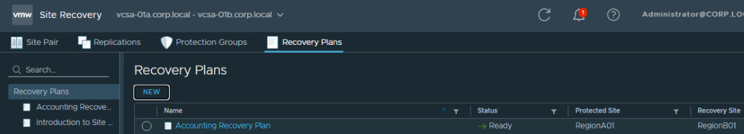

**Take a screenshot of the completed recovery Test.**

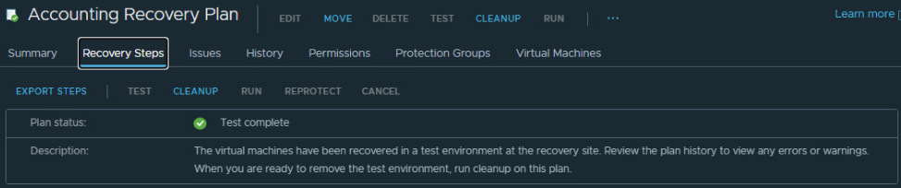

**Take a screenshot of your completed site-wide recovery.**

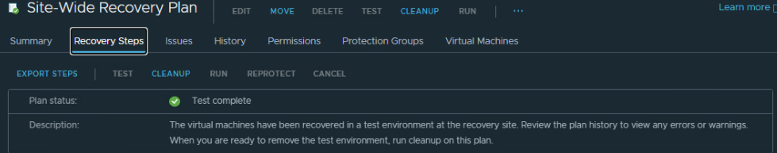

**Take a screenshot of all of the VMs running in the Region B data center.**

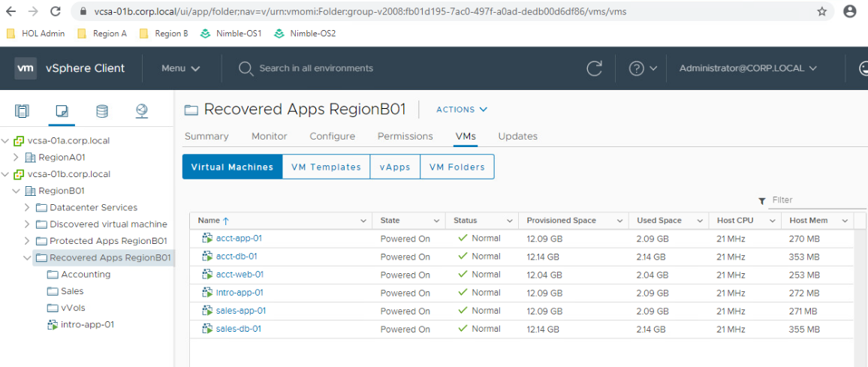

**Take a screenshot of the report.**

